**1. SEO Checklist**

The [SEO Checklist module](http://drupal.org/project/seo_checklist) is a useful list of recommended SEO best practices. It doesn't actually complete any work for you, but it does keep track of open and completed tasks. And best of all, it suggests SEO best practices to follow and other modules to install. Installation does require the Checklist API module. Beyond that, no configuration is required.

The checklist is divided into categories such as content, meta tags, and paths for easy navigation and understanding. It is highly recommended you follow the checklist to ensure your site follows all critical SEO best practices. As a bonus, the module will timestamp the new tasks you’ve completed each time you save the checklist.

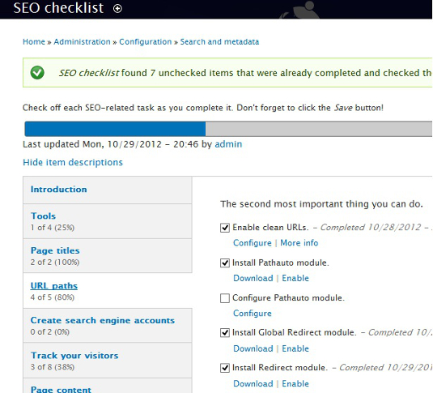

**2. SEO Compliance Checker**

The [SEO Compliance Checker](https://drupal.org/project/seo_checker) delivers feedback on the compliance of a preset series of user-defined rules. Upon creation or modification of nodes, the module will run a set of checks and display the results in a table, indicating what's perfect, and what might need a little help. Tested elements include title attributes <a href>, keyword density/usage, andatl <img> attributes.

**3. Page Title**

The [Page Title](http://drupal.org/project/page_title) module provides the administrator with the ability to control individual nodes, setting content in the<title> tag. It's one of the single most important elements in a successful SEO campaign, and a vital module.

**4. Path Redirect**

With [Path Redirect](http://drupal.org/project/Path_Redirect), administrators may redirect URLs from one path to another path. Using this module is important for maintaining the integrity of your site, and preventing search engine crawls from resulting in error. Additionally, links existing on external sites are preserved, and won't result in a 404.

**5. Global Redirect**

Global Redirect fixes duplicate URL bugs that tend to occur with clean URLs and the Pathauto module. Although aliases for URLs may appear different, they are in fact duplicate. With the [Global Redirect](https://drupal.org/project/globalredirect) module, a 301 redirect is created from the old node to the alias.

**6. Metatag**

The concept of meta tags is still a source of comedy. A great deal of weight used to be put on them, and hysteria ensued. The importance has decreased now, though use of the module can't hurt for providing structured metadata. In reference to SEO,[meta tags](https://drupal.org/project/metatag) include meta description tags and the meta keywords tag that search engines often pick up on.

**7. Search 404**

To ensure that "*Not all who wander are lost*" [Search 404](https://drupal.org/project/search404) performs a search on the keywords within a non-existing URL. The module does a fantastic job of keeping visitors on your site using search engine keyword detection and expression-based filtering from the URL. Search 404 is highly recommended to keep bounce rates down and user engagement up.

**8. XML Sitemap**

[XML Sitemap](https://drupal.org/project/xmlsitemap) generates a dynamic sitemap built for search engines, adhering to the specification of [sitemaps.org](http://sitemaps.org/). It enables you to configure content types, taxonomy terms and more for intelligent crawls from search engines.

**9. Site Verification**

The [Site Verification module](https://drupal.org/project/site_verify) helps with the verification process of your website. Supported methods of verification include adding meta tags or uploading a file. Once initiated, a bi-directional check is initiated, and search engines can then verify that you are the site owner.

**10. Google Authorship**

This is a standard for obtaining authorship information, and not quite a module. Implementing [Google Authorship](https://plus.google.com/authorship) can provide great ranking signals for authors with high credibility. All you have to do is get the authors on your site to create Google+ profiles, then add a rel="author" attribute. Details on adding user names in Drupal 7 can be found [here](http://adaptivethemes.com/add-rel-author-to-user-names-in-drupal-7).

**11. Links Checker**

The [Link Checker module](https://drupal.org/project/linkchecker) extracts links from content when saved, providing reports on failed responses. Quality issues such as broken links can be a negative signal to search engines.

**12. Taxonomy Title**

The [Taxonomy Title](http://drupal.org/project/taxonomy_title) module enables administrators to update the H1 for taxonomy term pages. Keyword-rich and accurate heading tags [e.g. H1, H2, H3] provide structure that is indicated to have some weight in SEO.

**13. HTML Purifier**

This module filters HTML to ensure rendered output is standards-compliant, removing all malicious code in the process. Without [HTML Purifier](https://drupal.org/project/htmlpurifier), users leave themselves open for XSS attacks, especially with WYSIWYG editors.

**14. Menu Attributes**

The [Menu Attributes module](https://drupal.org/project/menu_attributes) enables the administrator to target specific attributes, including id, name, class and styles. The module comes in handy when setting items to "nofollow", allowing for an effective linking strategy for your website.

**15. Footermap**

Search engines reward websites engineered for the best user experience. [Footermap](https://drupal.org/project/footermap) generates a site map block in the footer region to improve navigation. Use links sparingly and efficiently - there's a fine line between complete and spammy.

**16. Pathauto**

The [Pathauto module](https://drupal.org/project/pathAuto) is a staple of Drupal SEO, enabling keyword-rich paths for URLs. Enabling and utilizing Pathauto is double-value, ensuring search engines and site visitors may gather information on content through URLs.

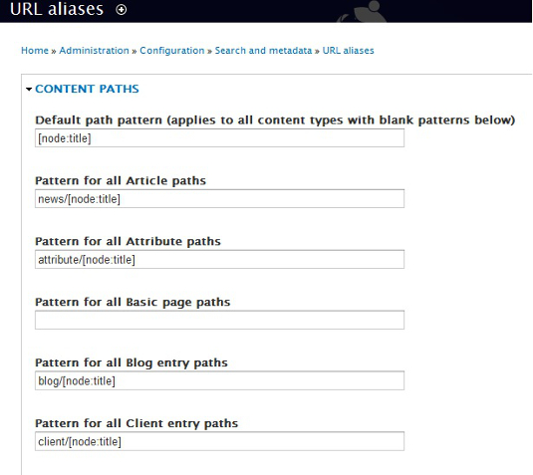

**17. Sub-Pathauto**

Automatically creates a new alias for URLs based on, or extending, an existing alias. [Sub-pathauto](https://drupal.org/project/subpathauto) allows for further generation of user-friendly URLS.

**18. Content Optimizer**

In tandem with Content Analysis, [Content Optimizer](https://drupal.org/project/contentoptimizer) provides statistics and recommended actions to boost search engine rankings. Level Ten provides a great [screencast of the Content Optimizer in action](http://getlevelten.com/tools/contentanalysis/seo/drupal/screencast). It's best considered as an integrated version of Google Analytics.

**19. Site map**

The [Site Map](https://drupal.org/project/site_map) module will give site visitors a complete view of the contents of your website, including blogs, categories, and more. Similar to XML sitemap, but more useful as an index page for the site. Drupal generates RSS feeds automatically.

**20. Google Analytics**

Once you've created an account in [Google Analytics](http://www.google.com/analytics/), you can go ahead and download the [Google Analytics module](https://drupal.org/project/Google_Analytics). From there, you'll have access to key insights on traffic, page logistics, and more. This is highly recommended for any SEO campaign.